Test Case: tc001_SPX_Dev5_Crear_Solicitud_Articulo_Almacen
Step 1 - Enter username and password and click to button Enter : Credentials Entered
Image file-name: QC_Testing-tc001_SPX_Dev5_Crear_Solicitud_Articulo_Almacen-1787862397968

Step 2 - Select to UEN and Access to Request for a New Inventory Item : UEN Correctly selected and Correct access
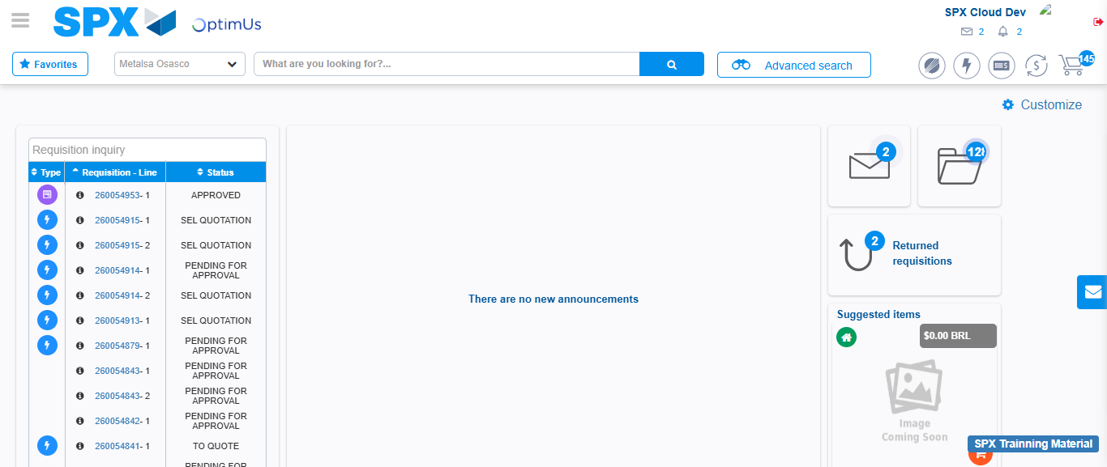Image file-name: QC_Testing-tc001_SPX_Dev5_Crear_Solicitud_Articulo_Almacen-1787862462470

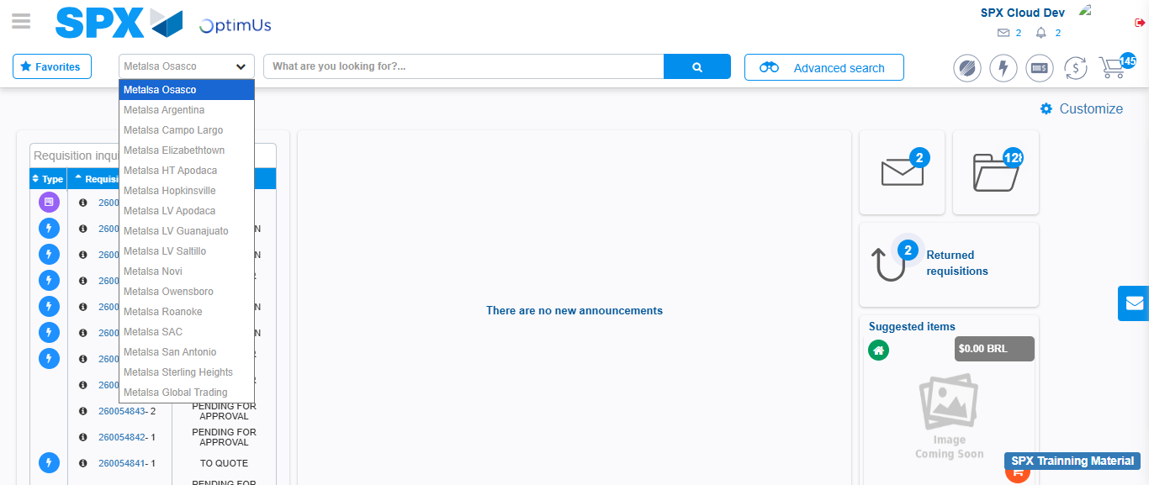Image file-name: QC_Testing-tc001_SPX_Dev5_Crear_Solicitud_Articulo_Almacen-1787862462953

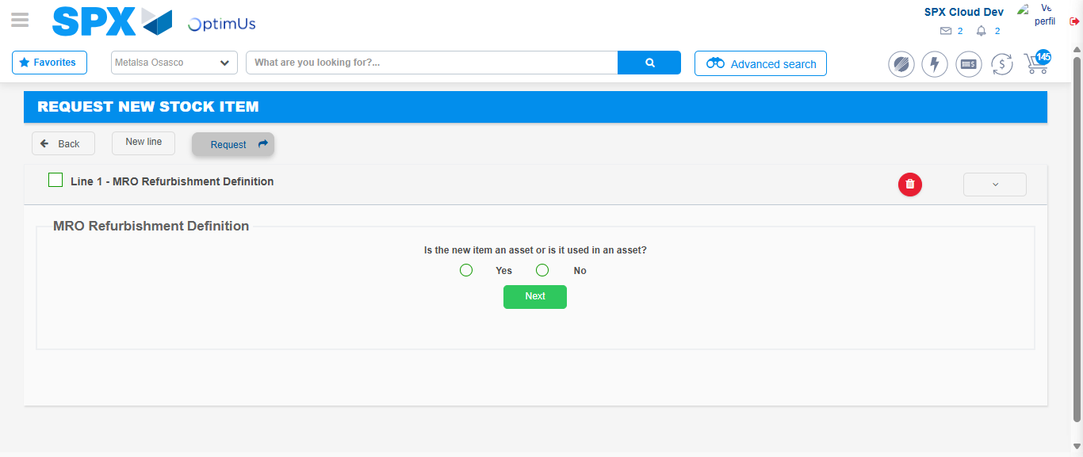Image file-name: QC_Testing-tc001_SPX_Dev5_Crear_Solicitud_Articulo_Almacen-1787862468525

Step 3 - Select options first section : Options seleted correctly
Image file-name: QC_Testing-tc001_SPX_Dev5_Crear_Solicitud_Articulo_Almacen-1787862468715

Image file-name: QC_Testing-tc001_SPX_Dev5_Crear_Solicitud_Articulo_Almacen-1787862468863

Step 4 - Select options section location and position: Options seleted correctly
Image file-name: QC_Testing-tc001_SPX_Dev5_Crear_Solicitud_Articulo_Almacen-1787862468715

Image file-name: QC_Testing-tc001_SPX_Dev5_Crear_Solicitud_Articulo_Almacen-1787862468863

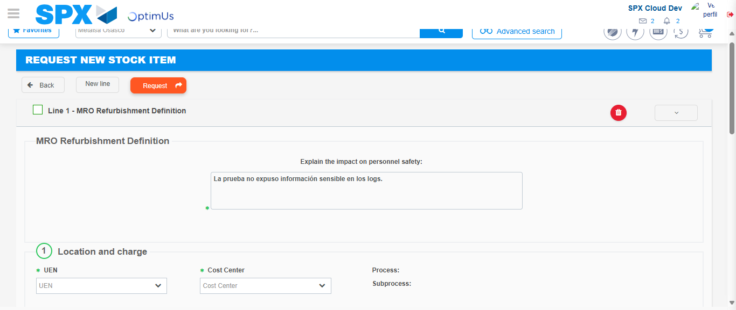Image file-name: QC_Testing-tc001_SPX_Dev5_Crear_Solicitud_Articulo_Almacen-1787862474626

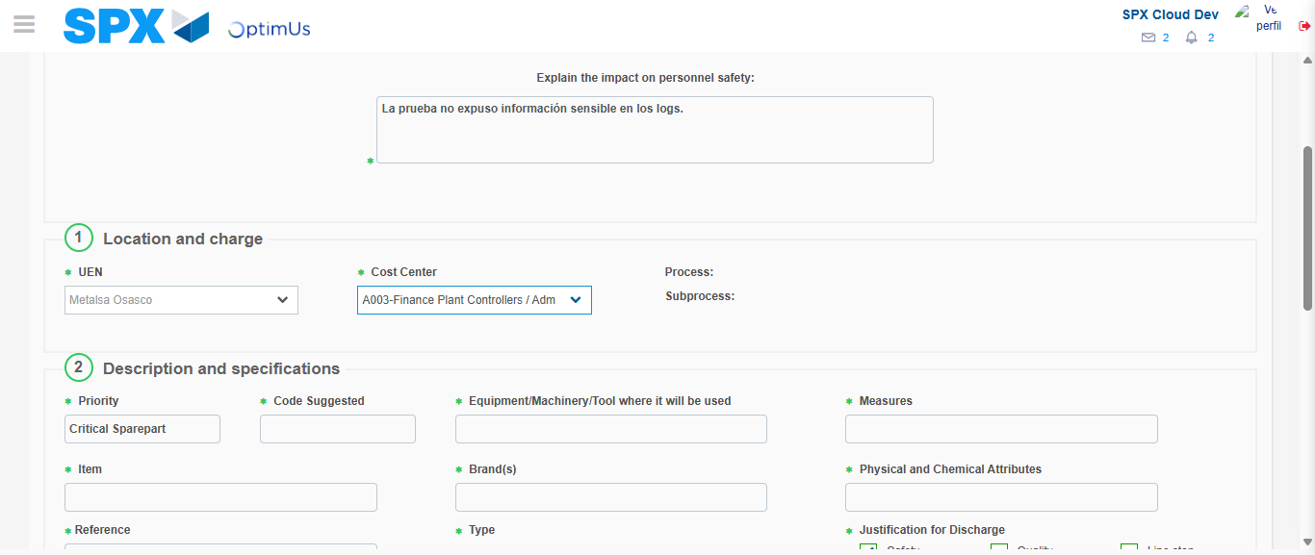Image file-name: QC_Testing-tc001_SPX_Dev5_Crear_Solicitud_Articulo_Almacen-1787862476988

Step 7 - Return to Main Page SPX : Return to Main Page SPX
Image file-name: QC_Testing-tc001_SPX_Dev5_Crear_Solicitud_Articulo_Almacen-1787862462470

Image file-name: QC_Testing-tc001_SPX_Dev5_Crear_Solicitud_Articulo_Almacen-1787862462953

Image file-name: QC_Testing-tc001_SPX_Dev5_Crear_Solicitud_Articulo_Almacen-1787862468525

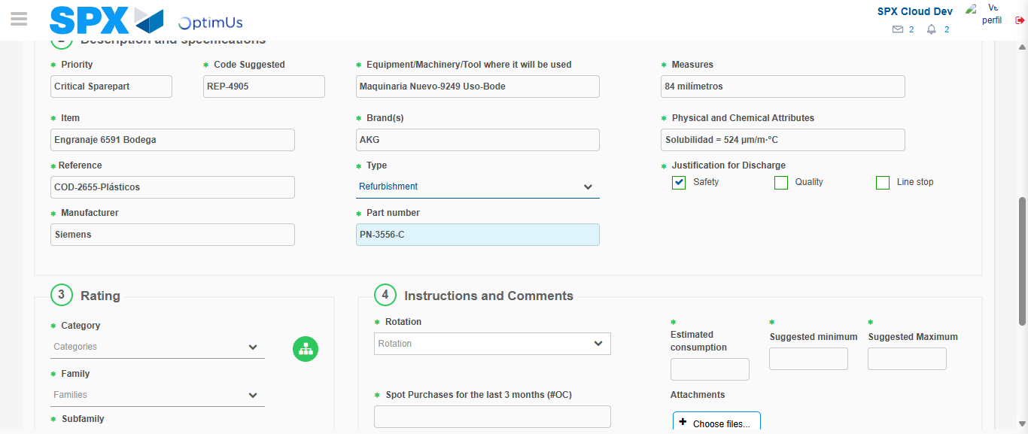Image file-name: QC_Testing-tc001_SPX_Dev5_Crear_Solicitud_Articulo_Almacen-1787862480295

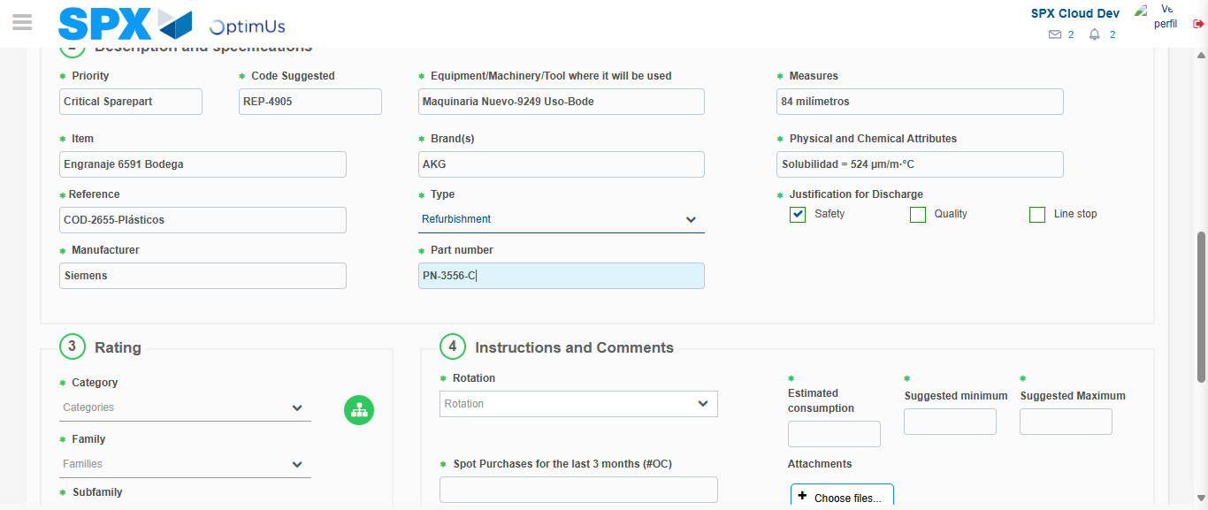Image file-name: QC_Testing-tc001_SPX_Dev5_Crear_Solicitud_Articulo_Almacen-1787862480451

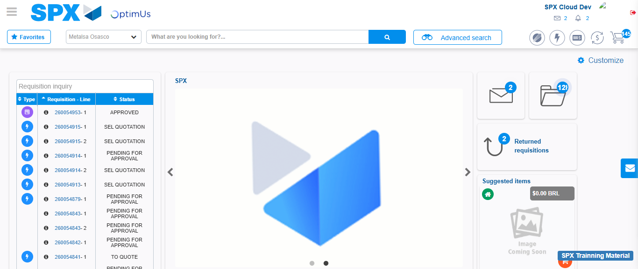Image file-name: QC_Testing-tc001_SPX_Dev5_Crear_Solicitud_Articulo_Almacen-1787862501442

Step 8 - Log Out : Log Out SPX
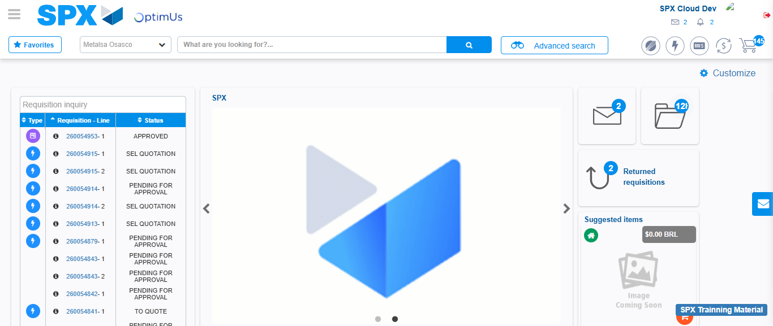Image file-name: QC_Testing-tc001_SPX_Dev5_Crear_Solicitud_Articulo_Almacen-1787862501679

